Safety Mandatory Education Test

1. Match the correct words to the blanks in the sentences. (label, two. hand hygiene, reduce)

a. Use at least ____ patient identifiers when providing care, treatment, and services.

- _______ all medications, medication containers and other solutions on and off the sterile field in perioperative and other procedural settings.

- __________ the likelihood of patient harm associated with the use of anticoagulant therapy.

- Comply with the Centers f Disease Control and Prevention (CDC) ___________ __________ guidelines.

2. Match the correct words to the blanks in the sentences.
(central line-associated, surgical site, multidrug-resistant organisms)

- Prevent healthcare-associated infections due to ________ - _________ ____________ (MDRO) in acute care hospitals.

- Prevent _________ _______-_________ bloodstream infections. (CLABSI).

- Implement evidence-based practices for preventing __________ __________ infections.

3. Match the correct words to the blanks in the sentences.
(suicide, medication reconciliation, mark, time out)

- __________ ____________ is a process for comparing a patient’s current medications with those ordered during a hospital stay.

- Identify patients at risk for ______________.

- ___________ the procedure site before the procedure is performed and with the patient involved, if possible.

- Conduct a _______ _______ immediately before starting the invasive procedure.

4. When an Emergency Code is called, employees should refer to the Disaster Preparedness Intranet home page and to the

a. Hospital operator
b. Red Emergency Management Guidebook
c. Emergency Department
5. Match the description to the appropriate code.

_____ Code Red A. Hazardous Material Spill Release
_____ Code Blue B. Adult Medical Emergency
_____ Code White, Pediatric Code C. Combative Person
_____ Code Pink D. Fire
_____ Code Purple E. Internal Disaster
_____ Code Yellow F. Severe Weather
_____ Code Gray G. Infant Abduction
_____ Code Silver H. Bomb Threat
Code Orange I. Weapon or Hostage Situation
Code Triage Internal J. Child Abduction
Code Triage External K. External Disaster
Code Weather L. Pediatric Medical Emergency
______Code Green M. Missing Person

6. Match the description to the appropriate triage alert.
- Potential disaster or hospital needs to begin preparations for a disaster.
- ED needs additional staff because its capabilities are taxed.
- Full activation of Incident Command.
- Systemic or area emergency department overload. Community capabilities are taxed.
____Code Triage: Stage 3, Surge Protocol
____Code Triage: Standby
____Code Triage: Stage 2, Hospital-wide
____Code Triage: Stage 1, ED

7. Match the words of the fire response plan to the correct RACE letter.

R _________________
A _________________
C _________________
E _________________

8. Match the words of how to use a fire extinguisher to the correct PASS letter.

P _________
A __ ______
S _________
S _________

9. To lift an object, I should bend at the knees and squat, using my large, strong _______muscles.

a. Ankle
b. Stomach
c. Leg
10. Munson employees are asked to report situations that violate laws, regulations or policies.

a. Except if the situation relates to a close coworker.
b. If it is convenient.
- For all situations.

11. What are two ways that an employee can obtain an MSDS for a hazardous chemical used at Munson?

- Go to the Munson Intranet.>eH>Supplies>MSDS or call the 3E Company.
- Call the MMC Safety Department or call Security.
- Call Loss Prevention or call Security.

12. At Munson Medical Center, how do healthcare workers best report all injuries, exposures, and near misses?

a. Call the Hospital operator at “0” or 1-800-4MUNSON
- Call the Risk Management Liaison
- Call your Manager, followed by your Director
- Call the Safety/Loss Prevention representative

13. If an employee is splashed or stuck by a sharp that is contaminated with blood or body fluid, what is the FIRST thing that should be done?

- Finish your shift before reporting the incident.
- Wash/Flush with water the part of body exposed.
- Call 5-5555 to report a Code Blue.
- Recognize that nothing needs to be done.

14. If a patient feels his/her rights have been violated, he/she should call the:

- Risk Management Liaison
- Recipient Rights Advisor
- Safety/Loss Prevention Representative
- Hospital operator at “0” or 1-800-4MUNSON

15. If abuse or neglect or assault is suspected, hospital personnel have the option of deciding NOT to report the incident.
True False

16. All of the following statements about electrical safety are true EXCEPT

a. Label unsafe electrical equipment with a Defective – Do Not Use sticker.
b. Remove unsafe electrical equipment from service.
c. Lock out/Tag out refers to using a lock to identify faulty equipment that needs the power
supply cut off for repair.
- Contact Environmental Services for equipment repairs.
17. What are the two recommended methods of hand hygiene at Munson Medical Center?

a. Aloe lotion, soap and water
b. Ultra violet light, soap and water
c. Olive oil, soap and water
d. Alcohol-based hand rub, soap and water

18. How long should hands be rubbed together for soap and water hand hygiene?

a. 5 - 10 seconds
b. 10 -15 seconds
c. 15 - 30 seconds
d. 30 – 40 seconds

19. Anyone who works in-patient care areas, food services, or who handles medications or sterile supplies is not allowed to wear acrylic fingernails or nail extensions. Additionally, nails must be free of dirt and trimmed to less than how long?

a. 1/16 inch
b. 1/8 inch
- ¼ inch
- ½ inch

20. What should be done with personal clothing that is stained with blood or body fluids?

a. Place contaminated clothes in laundry bag. Label with name, manager, department, date, and contents and send to MMC laundry.
b. Take contaminated clothes home for laundering.
- Wash clothes at a public Laundromat only.

21. If you miss three workdays in a row due to illness, get evaluated by a physician or by Employee Heath and fill out the Employee Reportable Conditions form.
True False

22. Match the disease to the appropriate type of isolation.

____Droplet
- Measles (rubeola)
- Influenza
- Scabies or staph
- TB (pulmonary)
____Contact
____Airborne – N95/PAPR
____Airborne – Surgical Mask

23. The respiratory protection that employees must wear when entering the room of a TB patient is
a. No respiratory protection is required as long as the patient remains in the special isolation room.
- A Positive Air Purified Respirator (PAPR) or an N95 respirator.
- A surgical mask

24. Patients who have an allergy to latex will wear a green armband that states, “Latex allergy.”
True False

25. “Minimum necessary” sharing of information means:

a. Employees must share as little as possible with a patient about his/her condition.
- Employees must share only the minimum protected health information (PHI) that is needed to perform a specific job.
- Employees must share only the minimum amount of information with his/her supervisor about each patient.

26. Employees may not discuss any patient information outside of work.
True False

27. Values, beliefs and practices are often similar within cultural groups, but may not be held by every member of that group.
True False

28. Taking the time to evaluate yourself for biases and stereotypes will cause you to disrespect others.
True False

29. What is unsafe in this picture?

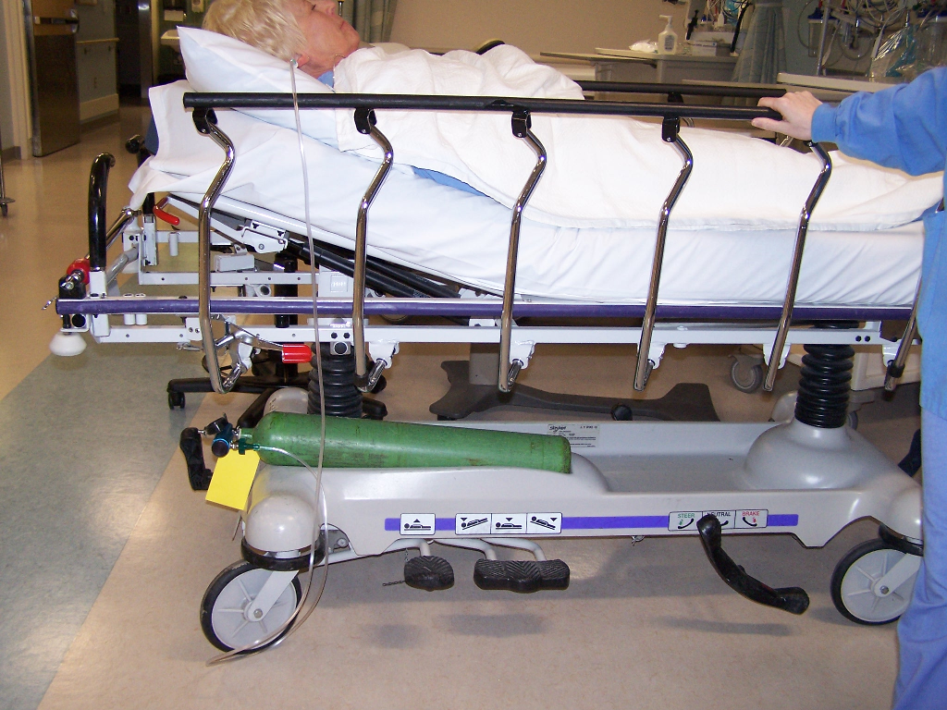
- Nothing is unsafe in this picture.
- The cylinder not properly secured.
- The tubing is dangling by stretcher wheels.

30. What is unsafe in this picture?
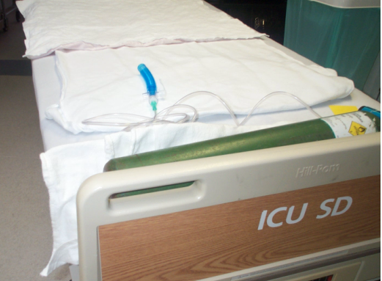
- Nothing is unsafe in this picture.
- The hospital worker in charge of cylinder should be within 6 inches of the cylinder at all times.
- The cylinder is not properly secured.

31. Matching: Place the letter of your choice in the appropriate spot.

Ways that each of us can help to secure the environment at MHC are:

a. Wear _____ badges at all times.
- Suspicious
- I.D.
- Buddy
- Employee

- Report _________ activity immediately.

- Park only in ________ designated areas.

d. Use the ___________ system whenever possible.

32. Workplace violence and threats will not be tolerated.
True False

33. Hospital security is a shared responsibility for all MHC workers.
True False

